**IMPACT OF BMI ON RENAL FUNCTION AND INCOME**

**Tharun Prabhakar**

**Katz School of Science and Health**

Table of Contents

Background 4

Study 1 4

Hypothesis: 4

Study 2: 4

Hypothesis 4

Methods 5

Study Design 5

Participants 6

Demographic Diversity 6

Sampling 6

Sample Size 6

Variables 6

Statistical Analysis 6

1. Descriptive Statistics 6

2. Inferential Statistics: 9

Data Analysis Software 11

Limitations 11

Results 12

Correlation Plot: 12

One Sample Z-test: 12

1. Hypothesis 12

2. Hypothesis 17

Analysis of Variance (ANOVA): 20

1. Hypothesis: 20

Null Hypothesis: There is no difference of mean urine flow rate between weight categories 20

Alternate Hypothesis: There is a significance difference in mean urine flow rate between weight categories. 20

Summary: 20

2. Hypothesis 20

Null Hypothesis: There is no difference of mean BMI between Income categories 20

Alternate Hypothesis: There is a significance difference in mean BMI between Income categories. 21

Summary: 21

Post Hoc Tests: 21

Hypothesis 21

Regression Analysis: 22

1. Hypothesis: 22

2. Hypothesis 23

Conclusions 24

References 25

# Background

Study 1**:**

Hypothesis:Urine Flow Rate of an individual is affected by the Body Mass Index (BMI) of that individual.

A vital physiological indicator of renal health, function, and fluid homeostasis in the body is urine flow. Blood pressure, hormone balance, and general levels of hydration are among the variables that affect it. Previous research has established a connection between body weight and renal function. Conditions like obesity have been linked to alterations in renal hemodynamics, increased glomerular pressure, and changes in hormonal profiles, potentially influencing urine flow. Hormones and inflammatory substances produced by adipose tissue may affect renal function and cause changes in urine flow in people with varying weight statuses. People who weigh more, especially those who are considered overweight or obese, are more likely to develop metabolic syndrome such as Diabetic ketoacidosis and insulin resistance, which are the two metabolic syndrome components that can cause kidney failure and changes in urine flow. While much attention is given to people who are overweight and obese, people who are underweight may also exhibit physiological changes to urine flow.

## Study 2:

Hypothesis**:** An Individuals Income has an effect on BMI.

As a measure of body fat, body mass index, or BMI, is a commonly used statistic to evaluate a person's body weight in relation to their height. BMI is a useful tool for health assessments since it divides people into four categories: underweight, normal weight, overweight, and obese (World Health Organization [WHO], 2000). Elevated body mass index (BMI) is linked to heightened chances of long-term health issues, such as diabetes, heart disease, and some types of cancer. On the other hand, underweight people may have various health issues including nutritional deficits (WHO, 2000). It is commonly known that socioeconomic status and health outcomes are related. One important socioeconomic factor that affects lifestyle choices, diet, and access to healthcare is income, which may exacerbate health disparities and higher-income individuals often have better access to healthcare resources and preventive services. This access can influence awareness and the ability to manage weight-related issues effectively (Adler & Ostrove, 1999). Studies show that opportunities for physical activity, access to healthcare, and dietary choices are all influenced by income levels. A healthy lifestyle may be more difficult to maintain for those with lower incomes, which could result in differences in BMI (Drewnowski & Almiron-Roig, 2010).

# Methods

Study Design**:**

A cross-sectional study design in suited for both the case studies as it allows simultaneous collection of data on Urine Flow, BMI Status, Income of individuals to get a snapshot of the samples at a specific point in time. Examining prevalence and associations is a good fit for the cross-sectional approach, which also fits with the objective of looking at possible differences in urine flow between weight categories and Income and weight categories. It is critical to recognize the cross-sectional design's limitations, especially when it comes to establishing causal relationships, even though it provides efficiency and insightful information. However, the results of this study can be used as a starting point for additional research and advance knowledge of the complex relationship between body weight and renal health and income and body weight.

Participants**:**

1. Age Range: The population contains the data of individuals who are above 18 years of age.
2. Absence of Renal Conditions: The individuals are considered such that they do not have any existing or chronic renal conditions that might affect the results of the test and provide biased results.
3. Health Status: Individuals should be in good health without significant chronic diseases that might independently affect urine flow.

Demographic Diversity**:**

The individuals are considered without any preference towards gender or race.

Sampling**:**

Simple Random Sampling is carried out to select random individuals to minimize selection bias and increase the study’s external validity.

Sample Size**:**

To get a difference in mean less than 0.2(approx. 0.2052006) a sample size of 500 has been selected using power analysis. This appropriate sample size ensures that it is sufficient to detect statistically significant differences in urine flow among the weight categories and between income and weight categories.

Variables**:**

* Independent Variable: BMI Factor.
* Dependent Variables: Urine Flow and Income.

Statistical Analysis**:**

1. Descriptive Statistics: The summary statistics of the population and sample is given below.

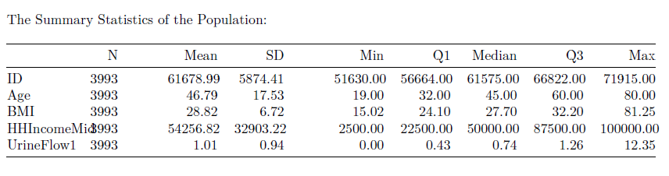

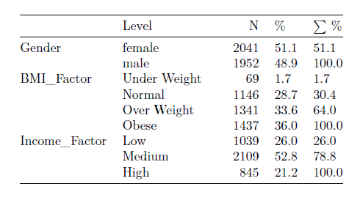

For the purpose of this study, we have taken “Age”, “Gender”, “BMI”, “HHIncomeMid”, “UrineFlow1” as features. Age is the age of the individual at that time, Gender gives us if that particular individual is a Male or Female, BMI is the Body Mass Index of that Individual at the time of measurement, HHIncomeMid is the midpoint of the household income, the midpoint is taken because it simplifies the analysis and maintains the privacy of survey respondents by not requiring exact income amounts, UrineFlow1 is the urine flow rate (mL/sec) which is calculated by dividing the volume of the urine sample collected by the time duration between the previous urine void and the urine sample collection. With the help of the BMI and Income features we created “BMI_Factor”, “Income_Factor” that provides the range or level at which the individual is of. From the above statistics we can see that there are 3993 observations. The Age feature has a minimum of 19, which means that the observations are of individuals who are above 18 years of age. The Population however has almost equal representation of Male and Female individuals.The Mean of BMI (28.82 kg/cm^2) which means that the feature is right skewed and has more individuals on “Over-Weight” and “Obese categories” and there are very less individuals who are “Under-Weight”. The Income_Factor column is created with individuals with income between 2500 and 22500 as “Low”, between 22500 and 87500 as “Medium” and between 87500 and 100000 as “High”. The BMI_Factor is created with individuals with weight less than 18.5 Kg/cm^2 as “Under-Weight”, between 18.5 to 25 Kg/cm^2 as “Normal”, between 25 to 30 Kg/cm^2 as “Over-Weight” and above 30 Kg/cm^2 as “Obese”.

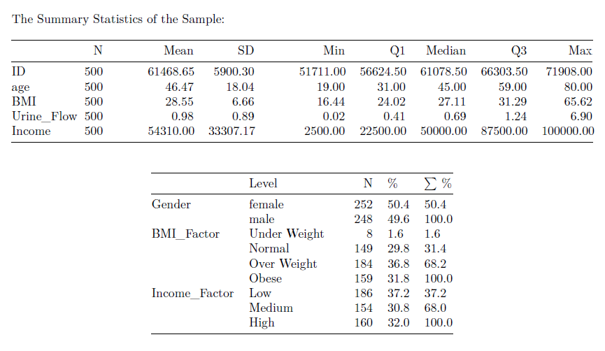

The sample of 500 individuals is taken at random from the population. We can see that there is equal representation of Male and Female Individuals. However, the sample has very less individuals who have BMI_Factor as “Under-Weight” which might affect the results of this studies.

### Inferential Statistics:

1. Pearson Correlation Coefficient Test**:**

Objective**:**

To determine the correlation coefficient between the variables to check if there is any relation between the variables considered in this study.

Procedure**:**

Correlation plot was used to identify the effects within the features.

Output**:**

Provides color plot with higher the intensity of color more is the effect between variable.

1. One Sample Z-test**:**

Objective**:**

To determine if there are statistically significant differences in mean urine flow between the categories and the actual population.

Procedure**:**

One Sample Z-test was conducted to test the null hypotheses that the sample mean is equal to the population mean or not.

Output**:**

Z-test indicates if the sample mean has significant difference compared to the population.

1. Analysis of Variance (ANOVA)**:**

Objective**:**

To check if there is any difference in the means of the sample between the weight categories (underweight, normal, overweight, obese) or Income Categories (Low, Medium, High).

Procedure**:**

One-way ANOVA was conducted to evaluate the null hypothesis that there is no significant difference in mean between different weight categories or income categories

Output**:**

ANOVA results indicated if there was a significant difference in means.

**3.** Post Hoc Tests**:**

Objective**:**

If ANOVA indicated significant differences, post hoc tests (Tukey's HSD) were employed to identify specific pairwise differences between the Income categories.

Procedure**:**

Tukey's HSD post hoc tests were used to identify statistically significant differences in mean of BMI between income categories.

Output**:**

Identified which income categories exhibited statistically significant differences in mean BMI.

**4.** Regression Analysis**:**

Objective**:**

To plot a regression equation and check if the equation can fit the set of data points.

Procedure**:**

Line Regression model was fit with Urine_Flow as dependent variable and BMI as independent variable to identify the intercept and coefficient in the first test and BMI as the dependent variable and Income as independent variable in the second test

Output**:**

Identified the regression equation and checked the significance and efficiency of the equation.

Data Analysis Software**:**

R-Studio SHA-256: FE62B784 | Version: 2023.09.1+494 |

Limitations**:**

* The data used to take sample was treated to remove null values in the population which can introduce selection bias that may impact the generalizability of the results.
* Using BMI as the sole indicator of the weight categories which might oversimplify the relationship between weight composition and renal function. It does not differentiate between lean body mass and adipose tissue.
* The “Under Weight” Category has less observations compared to other classes hence the result might be induced with a slight bias.
* The Population was not treated for outliers that might affect the results during Regression analysis.

# Results

## Correlation Plot:

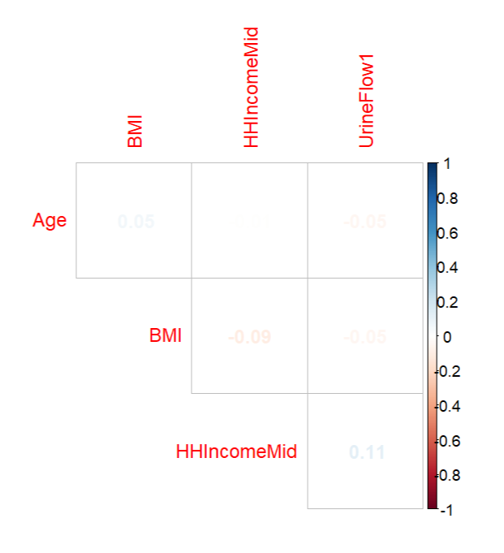

We can see that there is a mild association between BMI and Urine Flow Rate and a mild negative association between HHIncomeMid and BMI.

## One Sample Z-test:

1. Hypothesis**:** Urine Flow Rate of an individual is affected by the Body Mass Index (BMI) of that individual.

For this test the sample has been divided into 4 categories “Under-Weight”, “Normal”, “Over-Weight”, “Obese” and the test was conducted with Urine Flow rate of each category.

1. **BMI_Factor:** “Under Weight”

**Population Mean:** 1.00640 mL/sec

**Sample Mean:** 0.9295 mL/sec

**Z-test Score:** -0.2002546

**Null Hypothesis**: The sample mean is equal to population mean (xbar-mu=0)

**Alternate Hypothesis**: The sample mean is not equal to population mean (xbar- mu!=0)

**P-value two-tailed:** 0.8412814 (Accept Null Hypothesis p-value>0.05)

**Null Hypothesis**: The sample mean is equal or greater than population mean (xbar-mu>=0)

**Alternate Hypothesis**: The sample mean is less than population mean (xbar- mu <0)

**P-value One-Tailed Right:** 0.4206407 (Accept Null Hypothesis p-value>0.05)

**Null Hypothesis**: The sample mean is equal/less than population mean (xbar-mu<=0)

**Alternate Hypothesis**: The sample mean is greater than population mean (xbar- mu> 0)

**P-value One-Tailed Left:** 0.5793593 (Accept Null Hypothesis p-value>0.05)

This means we fail to reject the null hypothesis in all cases, indicating there is no significant statistical evidence to suggest that the sample mean is different from the population mean. The urine flow rate for the underweight category does not significantly differ from the expected population mean.

1. **BMI_Factor:** “Normal”

**Population Mean:** 1.00640 mL/sec

**Sample Mean:** 1.192541 mL/sec

**Z-test Score:** 2.390759

**Null Hypothesis**: The sample mean is equal to population mean (xbar-mu=0)

**Alternate Hypothesis**: The sample mean is not equal to population mean (xbar- mu!=0)

**P-value two-tailed:** 0.01681359 (Reject Null Hypothesis p-value<0.05)

**Null Hypothesis**: The sample mean is equal or greater than population mean (xbar-mu>=0)

**Alternate Hypothesis**: The sample mean is less than population mean (xbar- mu < 0)

**P-value One-Tailed Right:** 0.9915932 (Accept Null Hypothesis p-value>0.05)

**Null Hypothesis**: The sample mean is equal/less than population mean (xbar-mu<=0)

**Alternate Hypothesis**: The sample mean is greater than population mean (xbar- mu> 0)

**P-value One-Tailed Left:** 0.008406796 (Reject Null Hypothesis p-value<0.05)

From the result we can see that the sample mean of BMI is greater than the population mean. These results suggest that individuals with a "Normal" BMI have a higher urine flow rate than the general population, which is statistically significant.

1. **BMI_Factor:** “Over-Weight”

**Population Mean:** 1.00640 mL/sec

**Sample Mean:** 1.00652 mL/sec

**Z-test Score:** 0.001591493

**Null Hypothesis**: The sample mean is equal to population mean (xbar-mu=0)

**Alternate Hypothesis**: The sample mean is not equal to population mean (xbar- mu!=0)

**P-value two-tailed:** 0.9987302 (Accept Null Hypothesis p-value>0.05)

**Null Hypothesis**: The sample mean is equal or greater than population mean (xbar-mu>=0)

**Alternate Hypothesis**: The sample mean is less than population mean (xbar- mu < 0)

**P-value One-Tailed Right:** 0.5006349 (Accept Null Hypothesis p-value>0.05)

**Null Hypothesis**: The sample mean is equal/less than population mean (xbar-mu<=0)

**Alternate Hypothesis**: The sample mean is greater than population mean (xbar- mu> 0)

**P-value One-Tailed Left:** 0.4993651 (Accept Null Hypothesis p-value>0.05)

From the result we can see that the sample mean is equal to the population mean. The conclusion is that for individuals classified as overweight, there is no significant difference in urine flow rate compared to the general population.

1. **BMI_Factor:** “Obese”

**Population Mean:** 1.00640 mL/sec

**Sample Mean:** 0.958812 mL/sec

**Z-test Score:** -0.710129

**Null Hypothesis**: The sample mean is equal to population mean (xbar-mu=0)

**Alternate Hypothesis**: The sample mean is not equal to population mean (xbar- mu!=0)

**P-value two-tailed:** 0.4776242 (Accept Null Hypothesis p-value>0.05)

**Null Hypothesis**: The sample mean is equal/less than population mean (xbar-mu<=0)

**Alternate Hypothesis**: The sample mean is greater than population mean (xbar- mu> 0)

**P-value One-Tailed Right:** 0.2388121 (Accept Null Hypothesis p-value>0.05)

**Null Hypothesis**: The sample mean is equal/less than population mean (xbar-mu<=0)

**Alternate Hypothesis**: The sample mean is greater than population mean (xbar- mu> 0)

**P-value One-Tailed Left:** 0.7611879 (Accept Null Hypothesis p-value>0.05)

From the result we can see that the sample mean is equal to the population mean. This indicates that there is no statistically significant difference in the urine flow rate for obese individuals compared to the general population based on the provided data.

1. Hypothesis**:** An Individuals Income has an effect on BMI.

For this test the sample has been divided into 3 categories “Low”, “Medium”, “High” and the test was conducted with BMI of each category.

1. **Income_Factor:** “Low”

**Population Mean:** 28.82 Kg/cm^2

**Sample Mean:** 30.09 Kg/cm^2

**Z-test Score:** 2.035792

**Null Hypothesis**: The sample mean is equal to population mean (xbar-mu=0)

**Alternate Hypothesis**: The sample mean is not equal to population mean (xbar- mu!=0)

**P-value two-tailed:** 0.0417712 (Reject Null Hypothesis p-value<0.05)

**Null Hypothesis**: The sample mean is equal or greater than population mean (xbar-mu>=0)

**Alternate Hypothesis**: The sample mean is less than population mean (xbar- mu < 0)

**P-value One-Tailed Right:** 0.9791144 (Accept Null Hypothesis p-value>0.05)

**Null Hypothesis**: The sample mean is equal/less than population mean (xbar-mu<=0)

**Alternate Hypothesis**: The sample mean is greater than population mean (xbar- mu> 0)

**P-value One-Tailed Left:** 0.0208856 (Reject Null Hypothesis p-value<0.05)

From the result we can see that the sample mean is greater than the population mean. There is a statistically significant difference between the BMI of the sample and the population mean. The sample from the low-income group has a higher average BMI than the general population. This finding suggests a possible correlation between lower income levels and higher BMI, which may be attributed to factors such as access to nutritious food, health education, and lifestyle differences.

1. **Income_Factor:** “Medium”

**Population Mean:** 28.82 Kg/cm^2

**Sample Mean:** 29.87 Kg/cm^2

**Z-test Score:** 2.493383

**Null Hypothesis**: The sample mean is equal to population mean (xbar-mu=0)

**Alternate Hypothesis**: The sample mean is not equal to population mean (xbar- mu!=0)

**P-value two-tailed:** 0.01265323 (Reject Null Hypothesis p-value<0.05)

**Null Hypothesis**: The sample mean is equal or greater than population mean (xbar-mu>=0)

**Alternate Hypothesis**: The sample mean is less than population mean (xbar- mu < 0)

**P-value One-Tailed Right:** 0.9936734 (Accept Null Hypothesis p-value>0.05)

**Null Hypothesis**: The sample mean is equal/less than population mean (xbar-mu<=0)

**Alternate Hypothesis**: The sample mean is greater than population mean (xbar- mu> 0)

**P-value One-Tailed Left:** 0.006326614 (Reject Null Hypothesis p-value<0.05)

From the result we can see that the sample mean is greater than the population mean. In conclusion, individuals in the medium income category have a significantly higher BMI compared to the general population.

1. **Income_Factor:** “High”

**Population Mean:** 28.82 Kg/cm^2

**Sample Mean:** 27.04 Kg/cm^2

**Z-test Score:** -2.987004

**Null Hypothesis**: The sample mean is equal to population mean (xbar-mu=0)

**Alternate Hypothesis**: The sample mean is not equal to population mean (xbar- mu!=0)

**P-value two-tailed:** 0.002817256 (Reject Null Hypothesis p-value<0.05)

**Null Hypothesis**: The sample mean is equal or greater than population mean (xbar-mu>=0)

**Alternate Hypothesis**: The sample mean is less than population mean (xbar- mu < 0)

**P-value One-Tailed Right:** 0.001408628 (Reject Null Hypothesis p-value<0.05)

**Null Hypothesis**: The sample mean is equal/less than population mean (xbar-mu<=0)

**Alternate Hypothesis**: The sample mean is greater than population mean (xbar- mu> 0)

**P-value One-Tailed Left:** 0.9985914 (Accept Null Hypothesis p-value>0.05

From the result we can see that the sample mean is less than the population mean. In conclusion, individuals in the high-income group have a significantly lower BMI compared to the general population.

## **Analysis of Variance (ANOVA)**:

1. Hypothesis:Urine Flow Rate of an individual is affected by the Body Mass Index (BMI) of that individual.

Null Hypothesis: There is no difference of mean urine flow rate between weight categories

Alternate Hypothesis: There is a significance difference in mean urine flow rate between weight categories.

#### Summary:

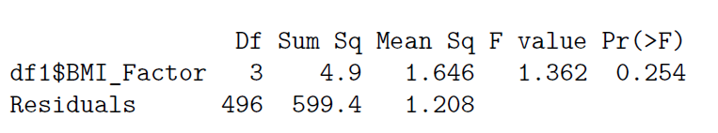

**P-Value:** 0.254 (Accept Null Hypothesis p-value>0.05)

This means that the analysis did not find a statistically significant difference in mean urine flow rate among different BMI categories.

1. Hypothesis**:** An Individuals Income has an effect on BMI.

Null Hypothesis: There is no difference of mean BMI between Income categories

Alternate Hypothesis: There is a significance difference in mean BMI between Income categories.

#### Summary:

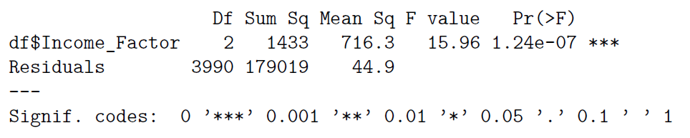

**P-Value:** 1.24e-07 (Reject Null Hypothesis p-value<0.05)

The test is significant that means there is a difference of mean the Income categories. Hence post hoc analysis is required.

## Post Hoc Tests:

Hypothesis**:** An Individuals Income has an effect on BMI.

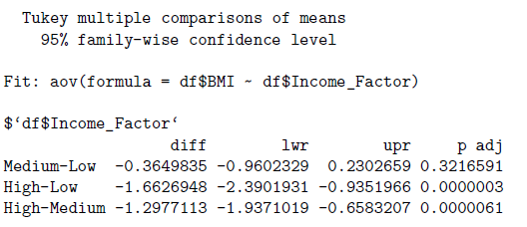

We can see that there is a difference of mean between High and Low and High- and Medium-income categories.

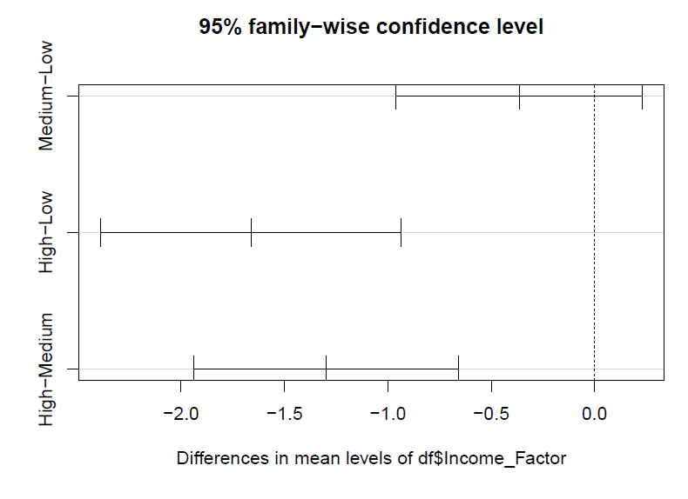

## Regression Analysis:

1. Hypothesis:Urine Flow Rate of an individual is affected by the Body Mass Index (BMI) of that individual.

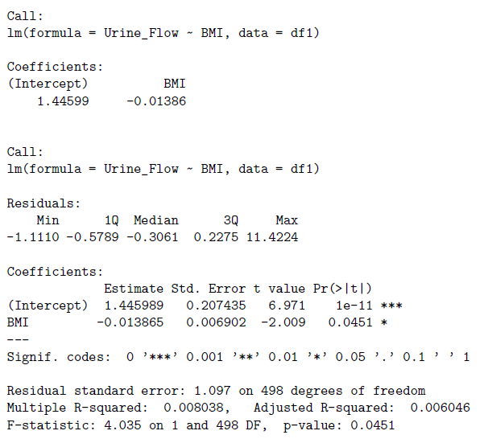

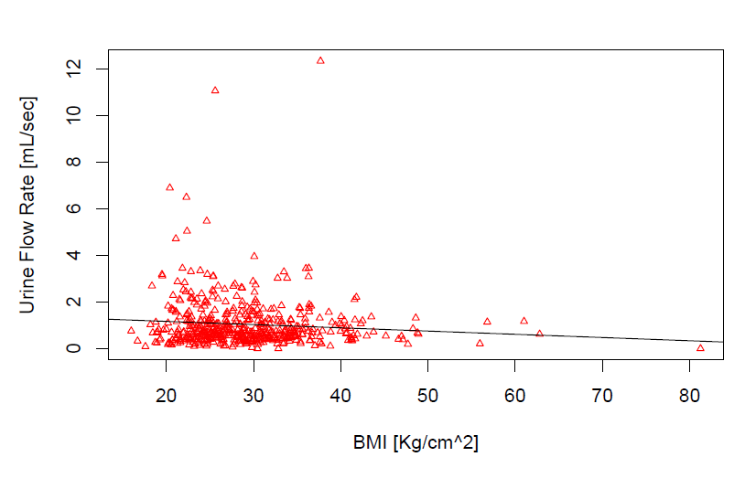

We can see that the regression line has a negative gradient and since the p-value is less than 0.05 the equation is insignificant, but from this we can see that as the BMI of an individual increases the urine flow rate tends to decrease.

1. Hypothesis**:** An Individuals Income has an effect on BMI.

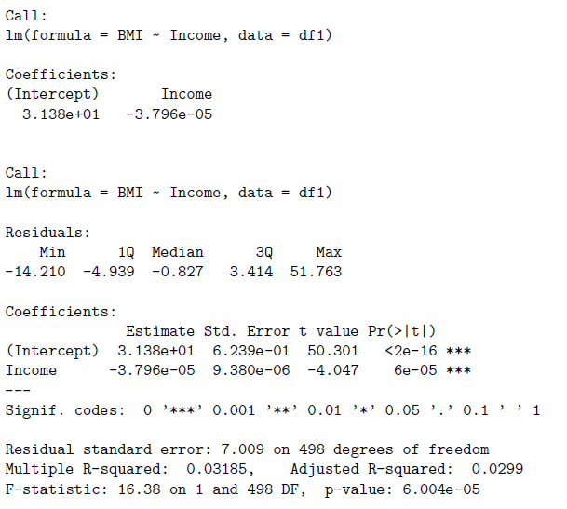

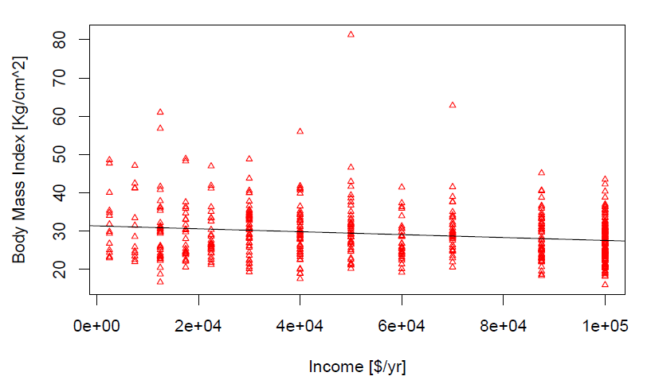

We can see that there is negative slope for the line this means that the BMI decreases when the individuals increase due to better affordability of health care systems and facilities.

# Conclusions

The study found no significant impact of Body Mass Index (BMI) on urine flow rate, suggesting that BMI does not directly affect renal function in the tested population. But, the regression analysis and correlation analysis indicate that there is a mild negative impact of BMI on Urine flow rate of an individual due to issues such as hypertension and diabetes caused by being over-weight or obese. These conditions can impair the kidneys' ability to filter blood and produce urine efficiently. Additionally, obesity can lead to increased fat deposits around the kidneys, potentially affecting their function and urine production. However, the findings did reveal a significant relationship between income levels and BMI, indicating that socioeconomic factors have a notable influence on BMI. This suggests that higher income levels may be associated with better health outcomes related to BMI, possibly due to greater access to healthcare and resources for maintaining a healthy lifestyle. The study highlights the importance of considering socioeconomic status in public health strategies aimed at addressing issues related to BMI and overall health.

# References

* Adler, N. E., & Ostrove, J. M. (1999). Socioeconomic status and health: What we know and what we don't. Annals of the New York Academy of Sciences, 896(1), 3-15.

<https://nyaspubs.onlinelibrary.wiley.com/doi/abs/10.1111/j.1749-6632.1999.tb08101.x?sid=nlm%3Apubmed>

* Drewnowski, A., & Almiron-Roig, E. (2010). Human perceptions and preferences for fat-rich foods. In Montmayeur J. P., le Coutre J. (Eds.), Fat Detection: Taste, Texture, and Post Ingestive Effects (pp. 265-290). CRC Press/Taylor & Francis.

<https://www.ncbi.nlm.nih.gov/books/NBK53528/>

* Kawakami, N., et al. (2002). Income inequality, social capital, and self-rated health in 45 countries. Social Science & Medicine, 54(6), 1321-1331.

<https://www.sciencedirect.com/science/article/abs/pii/S0277953607004534?via%3Dihub>

* World Health Organization. (2000). Obesity: preventing and managing the global epidemic (No. 894). World Health Organization.

<https://pubmed.ncbi.nlm.nih.gov/11234459/>